# Christopher Meloni Confirms Mariska Hargitay Will Appear on Upcoming *SVU* Spinoff

The two actors previously appeared together on *Law & Order: SVU* for 12 seasons

[Nicholas Rice](https://people.com/author/nicholas-rice/)

July 30, 2020 09:09 AM

F,{99ebce61-8673-4dff-86d8-1d7c8fc8ecc7}{168},3.125,3.125

[*Law & Order: Special Victims Unit*](https://people.com/tv/people-law-order-svu-special-edition/) fans, rejoice!

During an [appearance](https://www.youtube.com/watch?v=g4cRbelsoZw) on Wednesday's episode of [*The Talk*](https://people.com/tag/the-talk/), [Christopher Meloni](http://people.com/tag/christopher-meloni) revealed that [Mariska Hargitay](https://people.com/tag/mariska-hargitay/) will be making a cameo on the [upcoming *Law & Order* spinoff series](https://people.com/tv/nbc-announces-christoper-melonis-law-order-organized-crime-will-premiere-this-fall/) that was [previously announced](https://people.com/tv/christopher-meloni-reprising-law-order-svu-role-for-new-spinoff-series/) earlier this year.

After co-host [Sharon Osbourne](https://people.com/tag/sharon-osbourne/) asked the 59-year-old actor if Hargitay, 56, would be reprising her role as Olivia Benson on the series, Meloni confirmed, "Oh yeah!"

"How much? I don't know, because I hear she has her own day job," he added. "I think whatever we can slice away, whatever the writers come up with. I think we will both be looking forward to playing with each other in each other's sandbox."

The two actors co-starred on *SVU* for 12 seasons and the spinoff marks Meloni’s first time portraying his character Elliot Stabler in nine years, following his [sudden 2011 exit from the series](https://people.com/tv/christopher-meloni-is-he-leaving-law-order-svu/).

**RELATED:** [Stabler Is Back! Christopher Meloni Returns to *Law & Order* for *SVU* Spinoff Series](https://people.com/tv/christopher-meloni-reprising-law-order-svu-role-for-new-spinoff-series/)



**Mariska Hargitay and Christoper Meloni in Law & Order: SVU** NBCU Photo Bank

The spinoff series — titled *Law & Order: Organized Crime —* will follow Meloni's character as he leads the organized crime division of the NYPD. The show has already received a 13-episode order.

During his appearance on the CBS daytime talk show, Meloni also touched upon the return of his character after he was written off the show during its season 12 finale, where he retired from the police force.

Asked by co-host Sheryl Underwood if his character is a "changed man," Meloni said, "Yeah, absolutely. I mean, you have to."

"There are a lot of unanswered questions about how he left, why the silence vis-à-vis Olivia Benson," he continued. "I think, in real terms, society, and what we are dealing with in society, has changed dramatically. So, I think you have to address that. And, I think the person Elliot was, I think we all evolve. I think all those things are going to be put into play."

**RELATED:** [***SVU* Reunion! Mariska Hargitay Shares Selfie with Christopher Meloni: 'Easy Like Sunday Morning'**](https://people.com/tv/mariska-hargitay-shares-selfie-with-christopher-meloni/)

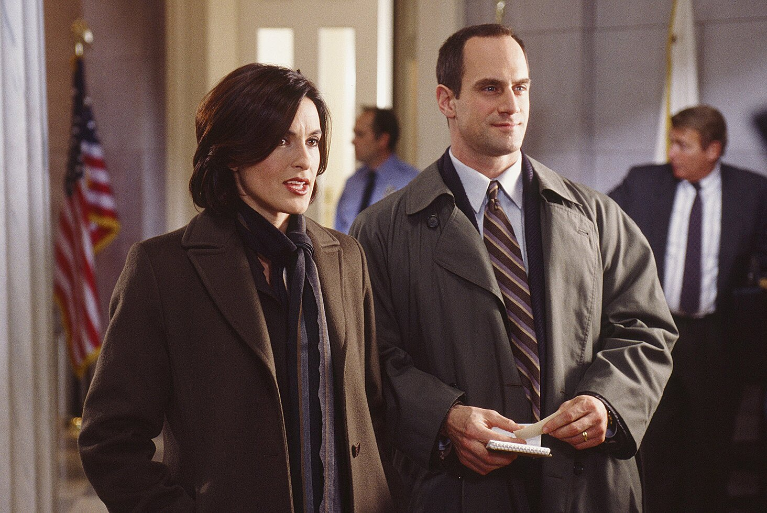

**Mariska Hargitay and Christopher Meloni in Law & Order: SVU** Craig Blankenhorn/NBCU

*SVU* showrunner Warren Leight previously revealed in an episode of the [*Law & Order: SVU Podcast*](https://www.nbc.com/law-and-order-special-victims-unit/exclusives/svu-podcast/video/4036795), that [Meloni will appear on *SVU*](https://people.com/tv/christopher-meloni-return-law-order-svu-season-22-premiere/) before the start of his spinoff series, so the Hargitay crossover is no surprise. Producer Dick Wolf is known for characters crossing over throughout his many shows and franchises, which include the three Chicago shows and two FBI shows.

"It’s pretty clear that Elliot will be in the *SVU* season opener," Leight said. "I think that much I know. Whether we get to see his family as well remains to be seen."

He added, "It's not just about the *SVU* season opener, it's how do we help launch the new series and how much crossover will there be between Elliot and Olivia as the season goes on."

**RELATED VIDEO: How 'SVU' Turned Mariska Hargitay into an Advocate for Rape Survivors**

But for now, production on Meloni's upcoming *Law & Order* spinoff is in flux amid the [coronavirus (COVID-19) pandemic](http://people.com/tag/coronavirus) according to the actor, who recently [gave an update on the project](https://people.com/tv/christopher-meloni-gives-update-law-order-spinoff/) during an appearance on SiriusXM's *The Jess Cagle Show.*

"We're in the middle of a pandemic production. You know, everything is just insane," he said. "You get new edicts out of New York City and New York state, and for good reason. And then you get new rules and regulations coming out of Universal, and then from the unions. You have to service a lot of masters right now, just to make sure everybody is safe, right? What's the new norm for shooting?"

"So that is the long way of saying the writers are breaking rocks, trying to figure out the arc of the story, who the characters are and how they interact, and I have yet to see a script," he said, jokingly adding, "I'm working on my tan, okay?"